** Entity Framework Project**

**Trading Company**

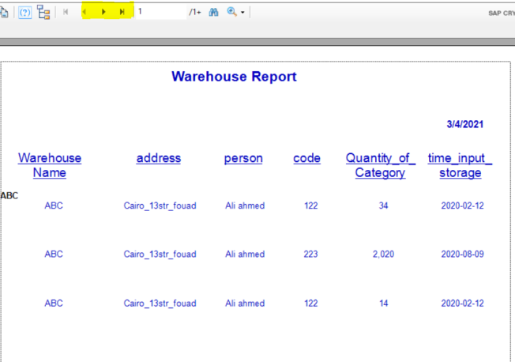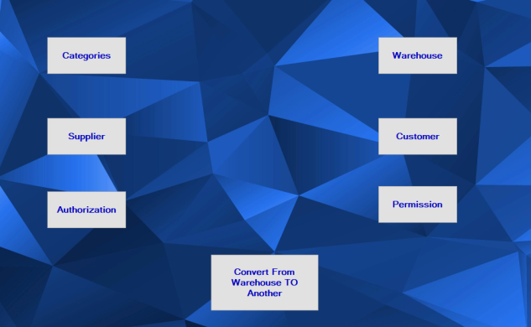

* The First Page Has 7buttons When You Click To( Warehouse Or Category Or Supplier) You Will Show The Reports.
* In Page (Convert) You Don’t Write The Start And The End Date Of The Category You Will Show The Date When You Click (Convert)
* In Reports(Each Warehouse Or Each Category)

You Will Click To (< >) To Show All Element Because Each Element In Page